Math 4 Name_______________________________

**4-2 Practice** Date________

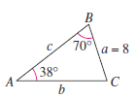**Use the Law of Sines or Cosines to find the missing side lengths and angle measures of the triangles shown or described below. Round side lengths to the nearest hundredth, and angles to the nearest whole number.**

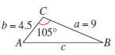

1.

2.

3.  4. 

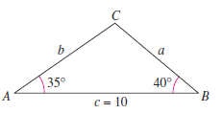

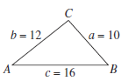

5. 6.

**Use the Law of Sines or Cosines to answer the questions below. Round side lengths to the nearest hundredth, and angles to the nearest whole number.**

7. A triangular parcel of ground has sides of lengths 725 feet, 650 feet, and 575 feet. Find the measure of the largest angle.

8. Because of prevailing winds, a tree grew so that it was leaning  from the vertical. At a point 40 meters from the tree, the angle of elevation to the top of the tree is  Find the height of the tree.

9. A flagpole at a right angle to the horizontal is located on a slope that makes an angle of  with the horizontal. The flagpole’s shadow is 16 meters long and points directly up the slope. The angle of elevation from the tip of the shadow to the top of the pole is 

a. Draw a triangle to represent this situation. Show the known quantities on the triangle, and use a variable to indicate the height of the flagpole.

b. Find the height of the flagpole.

10. On an MLB regulation baseball field, the pitcher’s mound is 60.5 feet from home plate and there is a distance of 90 feet between bases (home to first, first to second, etc). How far is it from the pitcher’s mound to third base?